**96 = 6 x 16**

**96 = 2x3x2x2x2x2**

**=4**

**216 = 2x108**

**216 = 2x54x2**

**216 = 2x2x27 x2**

**216 = 2x2x3x3x3x2**

**6**

**98=2x49**

**98=2x7x7**

**7**

**18=2x3x3**

**3**

**72=2x36**

**72=2x12x3**

**72=2x3x2x2x3**

**6**

**144=12x12**

**144=3x2x2x3x2x2**

**3x2x2=12**

**45=3x3x5**

**3**

**175=5x35**

**175=5x5x7**

**5**

**343=7x49**

**343=7x7x7**

**7**

**12=3x2x2**

**2**

**10**

**96=2x48**

**96=2x2x24**

**96=2x2x2x12**

**96=2x2x2x2x6**

**96=2x2x2x2x2x3**

**x2 =4**

**40**

**9**

**245=5x49**

**245=5x7x7**

**Now, it’s your turn!**

**2006 SOL Math 7**

**2. 19 -> -7 difference is 26!**

**3. 3 1/8 is close 3 inches.**

**½ in = 3 mi**



**3 in = 18 mi**

**5.**

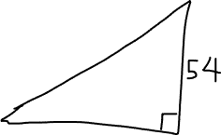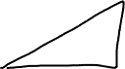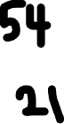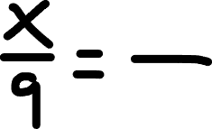

**9*54 = 21*x**

**486 = 21*x**

**X=23**

**7. 10% = 150**

**5% = 75**

**15.**

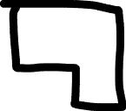

**176 + 18 = 194**



**19.**

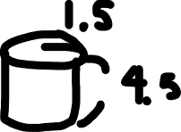

**26. translate horizontally -5**

**= move everything 5 units to the LEFT**

**L: (2,-2) -> (-3,-2)**

**Pythagorean Theorem**